Assessment Committee 4-4-22
Meeting NOTES

Agenda Item: Discussion of the future of assessment at CCC. What do we want assessment to look like post-pandemic (is that even a thing??) and after Year Seven of the accreditation cycle? Is it time to consider some significant changes for the near future? Now is the time to envision a path, so that we can plan ahead and so that we can articulate this vision in our accreditation report, which will be drafted over the next few months.

Where are we, after almost seven years of program assessment?

Strengths
- Growth in faculty understanding of learning outcomes assessment and experience with it
- Increase in program-level perspective (such as how one course fits into a larger whole)
- More teaching and curriculum decisions are guided by evidence (learning results, student feedback)
- We have a system of regular reporting and the results are used to guide assessment support, teaching & learning support and the assessment system overall
- Assessment and professional development are integrated in the Center for Teaching & Learning (something the Midcycle evaluators noted)*
- Assessment Committee helps guide assessment
- The NWCCU issued a Warning (a public sanction) that our accreditation may be in jeopardy in the summer of 2016 due to program assessment and the work we did resulted in the NWCCU removing the Warning (also referred to as “Notice of Concern”) in the summer of 2019**
- Structural: program assessment leads and assessment coaches
- Thinking about how to structure so that work is ongoing; prioritizing work and making it regular part of our practice (takes a long time!)

Challenges
- We don’t have an intentional approach to, support for, or reporting for, equitable assessment and learning improvement
- About 70% of programs report each year (is this a problem? what should the percentage be and why?)
- Accountability and accreditation are still perhaps a bigger motivator for some (in other words, “tell me what to do to meet requirements” versus “we’re doing this because it’s useful and central to our work”)
- We know that a portion of programs each year report that assessment informed actions but we don’t know if these actions have helped students
- The focus on summative assessment and PLOs maybe doesn’t leave as much room for using course-level formative assessment to help students

Contributing factors to challenges?
- Pandemic, etc
- Budget crisis, potential layoffs, ARE
- Multiple competing college-wide initiatives/issues
- Academic programs that are understaffed
- Some faculty say that their dean rarely pays attention to assessment and only if they don’t submit their report. Some say they don’t get the sense that executive leadership prioritizes--or really ever mentions--assessment anymore, compared to 2016-18
- Our reporting system? (focus, structure)
- The removal of the accreditation warning? Did we need this motivator? Is our system and approach designed too much in response to this (despite our best efforts otherwise)?
- Culture of continuous improvement - reactive instead of proactive
- Faculty contracts and how instructors are evaluated - some interpret as any indication that I am trying to improve is dangerous (we’re working on but also is resistance to working on it)
- Institutional structure - how cultural pieces are reinforced by structure - lack: everything that happens after reporting - not as focused ont he follow-thru and active part from admin - tightrope not being too prescriptive to induce fear etc - but feedback. How we use assessment - how could we use it in a more integrated and meaningful way? More relevant more focused on info needed.
- Shared governance - where are we/should we (assessment committee) be located in that process and structure? How might assessment of learning outcomes fit into the information used in decision-making etc? Any big changes to assessment would interact with shared governance.
- It seems like certain individuals spear head the process and when they leave, the momentum is gone. Needs to be an ethos of dept’s responsibility.

Where do we go from here?

What is our Guiding Star?
The overarching goal of assessment should be learning improvement
- Broad definition: Demonstrable learning improvement that results from interventions in the learning environment aimed to improve learning
  - Students don’t learn more simply by being assessed
  - Changes to an educational environment do not necessarily mean students will learn more
- Learning improvement at scale: efforts that improve the outcomes of all students who complete a degree or certificate program
- Program-level examples: learning-improvement.org
  - Waubonsee CC https://www.learning-improvement.org/infolit-history-waubonseecc
  - University of Alabama https://www.learning-improvement.org/story-consumersciences-ua

- DMC (2021): “We recognized that the improvements that we have made to the Portfolio class since our last assessment of this PLO have dramatically improved the quality of the student work.”

- Institution-level example of learning improvement:

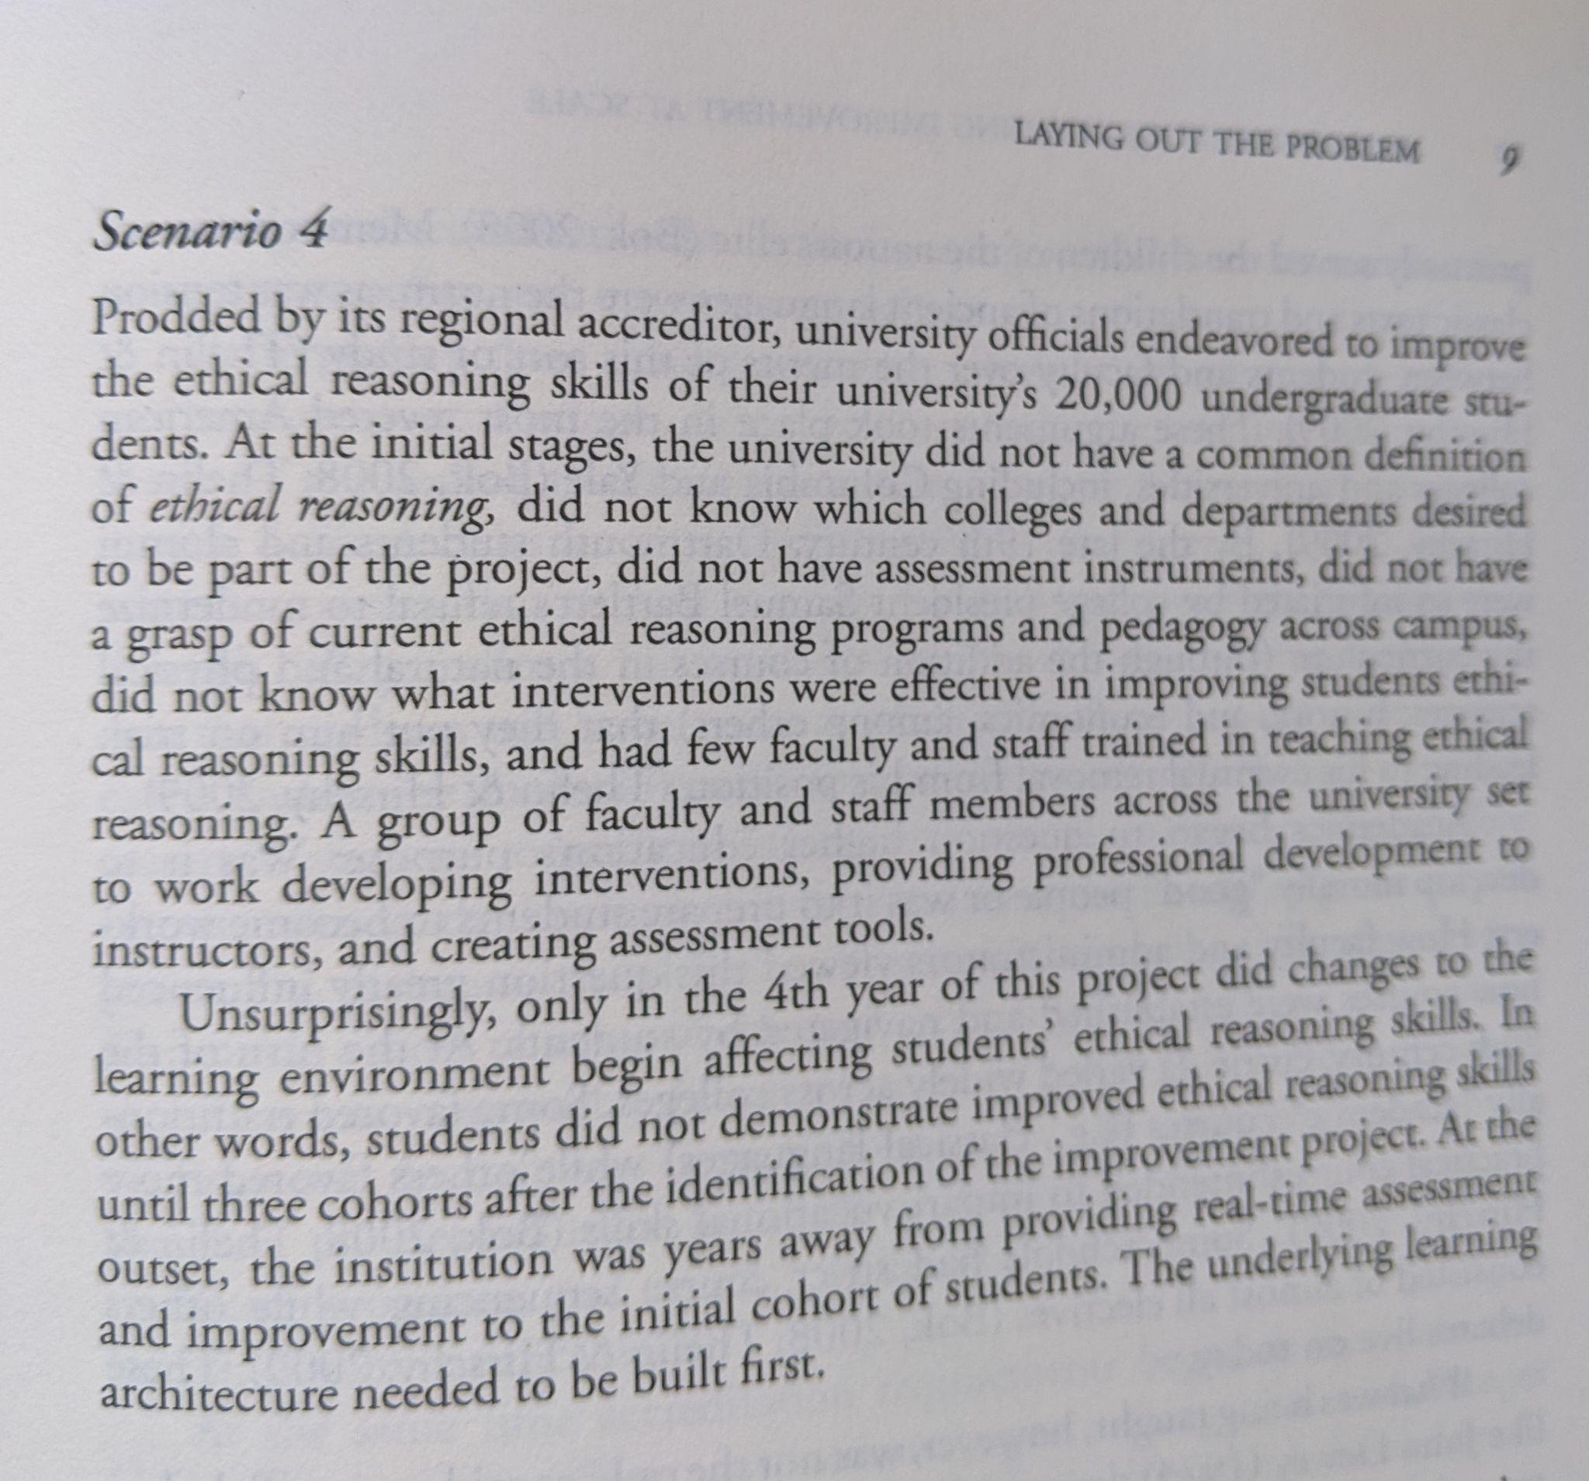
Excerpt from Fulcher & Pendergast (2021) Improving student learning at scale

How does our current assessment system & practices support or not support learning improvement?

Options for consideration
- Change reporting structure:
  - Longer report cycle - two or three years - to allow time for learning improvement efforts
  - Yearly report but with options: 1) assess 2) learning improvement 3) reassess (PCC example)
- Identify a focus for a learning improvement project(s) that would have an impact on many students, such as a few high-enrollment courses with general education learning outcomes. Pilot a process of learning improvement with guidance and support.
  - Year One: Define exactly what we mean by the outcome(s) of focus; collect baseline data
  - Year Two: Figure out the changes in the learning environment that need to occur and how to ensure that all faculty in the intervention course sections or course sequence are prepared to make those changes
  - Years Three-Four: Implement intervention and reassess

We want improvement and at the same time, we want to ensure that student learning is not dropping below an acceptable level…we want a way to monitor broadly…yes?

If we’re on a multiple year cycle, do we have the people power to do all at the same time?

What might be common across all three types that you are trying to assess?

*From the Midcycle Evaluation Peer Evaluation Report, April 4-5 2019: “The evaluation team provides the following formative feedback and suggestions to help the College prepare for the Year Seven accreditation report and visit.

1. Program assessment. Reviewing program assessment processes and practices at the College was a particular emphasis of the evaluation team’s work. In our meetings with both faculty and administrators, we confirmed that the College has made significant progress in the systematic assessment of instructional program outcomes. Faculty professional development activities are thoughtfully aligned with assessment work, and the College’s Assessment Coordinator provides faculty with substantive support and guidance. As a result, faculty as a whole are meaningfully engaged in assessment work and are beginning to use assessment data to improve teaching methods and curriculum. The College is effectively building a faculty-driven program assessment system that fosters a culture of inquiry.
Suggestion. The College should continue to refine and systematize program assessment procedures to ensure that all program outcomes, related area of instruction outcomes, and general education outcomes are regularly assessed and that the assessment results inform College decision-making processes.”

** Excerpt of letter with accreditation results, June 2019:
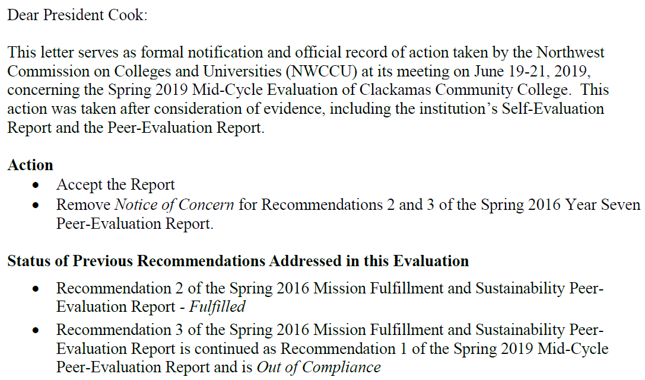

 | 2018 | 2019 | 2020 | 2021
Assessment Report Submitted | 92% (44/48) | 69% (33/48) | 75% (35/47) | 68%  (32/47)
Assessment Plan Submitted | 94% (45/48) | 71% (34/48) | 70% (33/47) | 60%  (28/47)

